Child wasting and diarrheal diseases positive feedback model

# Diagram

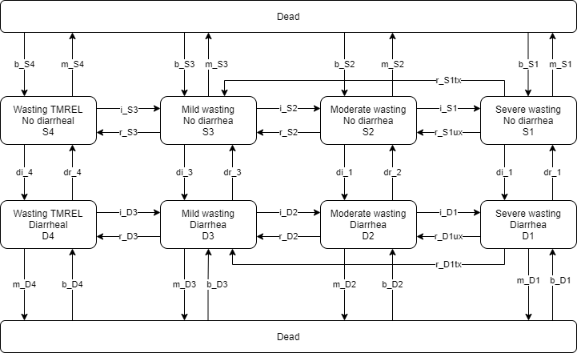

# Variable notation

### States

|  |  |  |
| --- | --- | --- |
| **Category** | **Notation** | **Note** |
| Wasting TMREL | 4 | cat4 in GBD |
| Mild wasting | 3 | cat3 in GBD |
| Moderate wasting (MAM) | 2 | cat2 in GBD |
| Severe wasting (SAM) | 1 | cat1 in GBD |
| Susceptible to diarrheal diseases | S |  |
| Infected with diarrheal disease | D |  |
| Overall population | O | Note, not a specific state, but meant to represent the population level aggregate |

## Transitions

All transition rates will be defined in terms of the count of transitions per person-time unit in the entire model system (not specific to person-time in the source state).

|  |  |  |  |
| --- | --- | --- | --- |
| **Transition category** | **Notation** | **Definition** | **Note** |
| Mortality | m_{source state} | Mortality rate specific to the source state multiplied by the prevalence of that state |  |
| Birth | b_{sink state} | Rate of aging into the sink state | “Reincarnation” or “aging into” states to keep population size stable |
| Diarrheal incidence | di_{wasting state} |  |  |
| Diarrheal remission | di_{wasting state} |  |  |
| Wasting incidence | i_{sink state} |  |  |
| Wasting remission | r_{source state} |  | Rate out of severe wasting state dependent on treatment coverage |

# Known Relationships

Known variables:

* Mortality rates (GBD)
* Overall population level wasting prevalence (GBD) and transition rates (dynamic transition model)
* Overall population level diarrheal transition rates and prevalence (GBD)
* Relative risks for diarrhea mortality by wasting state (GBD)
  + NOTE: The input data for these GBD relative risks are informed by diarrheal diseases mortality rates and GBD applies them equally to YLDs and YLLS. We are making the assumption that these relative risks apply to the diarrheal diseases excess mortality rate.
* Prevalence ratio for wasting states by diarrheal status (as estimated externally using GBD-informed data)

|  |  |  |
| --- | --- | --- |
| **Variable** | **Definition** | **Value** |
| ACMR | All-cause mortality rate from GBD | GBD 2019 age/sex/date/location-specific value |
| m_{state} | Wasting and diarrheal state-specific mortality | GBD 2019/2020: |
|  | Wasting relative risks for wasting-affected causes | GBD 2020 wasting risk effects model |
|  | Diarrheal disease PAF attributable to wasting | GBD 2020 wasting risk effects model |
|  | Population level incidence rate of diarrheal diseases | GBD 2019 diarrhea diseases cause model |
|  | Population level remission ate of diarrheal diseases | GBD 2019 diarrhea diseases cause model |
|  | Wasting model transition rates | GBD 2020 wasting dynamic exposure model |

1. We assume a constant population size. Therefore, the total mortality rate across all model states (exit from the population) is equal to the total birth/aging rate into all model states:
2. The mortality rate out of each state is equal to the state-specific mortality rate from GBD (known values) multiplied by the prevalence of that state.
3. The birth rate into each state is equal to the ACMR multiplied by the prevalence of that state (known values)
4. The overall population-level () incidence and transition rates from the dynamic exposure model for wasting are the sum across each transition such that:

(Where may equal i1,i2, or i3 and may equal t1,r2,r3,r4).

1. The diarrheal disease incidence rates vary according to the wasting-state relative risks for diarrheal diseases such that (scaled to prevalence):
2. We assume that the diarrheal diseases remission rate does not vary by wasting state and equals the population level remission rate scaled to state prevalence:
3. We assume a steady-state model. Therefore, the sum of the rates into a state is equal to the sum of the rates out of that state for all states. For example:
4. The ratio of wasting prevalence values across diarrheal states are equal to the wasting state-specific RRs custom calculated by Nicole here <https://github.com/ihmeuw/vivarium_research_ciff_sam/blob/main/wasting_transitions/11_June_2021_diarrhea_and_wasting_prevalence_ratio_calculation.ipynb>
5. (For now) We assume recovery rates for wasting states across diarrheal states are equal such that they are equal the population level rate scaled to state prevalence.

NOTE: Bitew et al. 2020 reported that children with diarrhea were 0.86 times as likely to respond to SAM treatment than children without diarrhea. Consider incorporating this into the model.

**FIRST: Solve for prevalence (8 unknown values)**

|  |  |  |
| --- | --- | --- |
| **Number** | **Equation** | **Reformatted** |
| 1 |  |  |
| 2 |  |  |
| 3 |  |  |
| 4 |  |  |
| 5 |  |  |
| 6 |  |  |
| 7 |  |  |
| 8 |  |  |

With these prevalence values, mortality, birth, diarrheal incidence, diarrheal remission, wasting remission rates become known values under the stated assumptions.

**Now, solve for unknown incidence rates:** (6 unknowns: )

|  |  |  |
| --- | --- | --- |
| **Number** | **Equation** | **Reformatted (unknown variable on right hand side, known constants on left hand side)** |
| 1 |  |  |
| 2 |  |  |
| 3 |  |  |
| 4 |  |  |
| 5 |  |  |
| 6 |  |  |